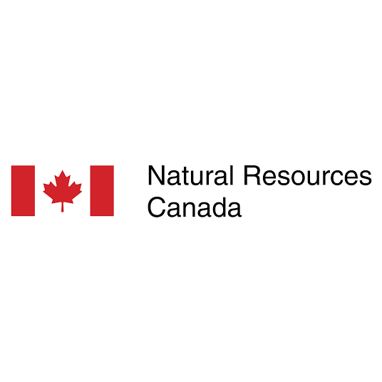

APPENDIX I: The CATCH Database Project
Canadian ThermoCHronology (CATCH) – NRCan National Thermochronology & Thermal History Data Project

Project Overview: The Canadian ThermoCHronology (CATCH) database initiative is a landmark collaboration between Natural Resources Canada (NRCan), the Geological Survey of Canada (GSC), and Lithodat. Before this project, the GSC lacked a standardized digital framework for managing complex thermal history data. Lithodat was engaged to engineer the national data model, design the database architecture, and execute a massive "data rescue" operation to extract and harmonize 50 years of Canadian geological research.
Lithodat provided the essential technical foundation, architecting the relational schema and populating it with "clean," standardized data, enabling NRCan to successfully migrate this information into their internal national data systems.
1. Executive Summary
1.1 What is the CATCH Database?
The Canadian ThermoCHronology (CATCH) database is a comprehensive national repository for low-temperature thermochronology data from across Canada. The database integrates 996 fission track datapoints and 762 (U-Th)/He datapoints from 1,427 unique samples, further divided into:
16,277 single grain fission track measurements
27,848 fission track length measurements
3,230 aliquots of (U-Th)/He data
The project represents a multi-year collaboration between Lithodat Pty Ltd and Canada's Geological Survey (Natural Resources Canada), involving extensive data mining, legacy data digitization, quality control, and standardization across 91 different data sources spanning five decades (1970-2021).
1.2 What is Low-Temperature Thermochronology? Low-temperature thermochronometers, such as fission track and (U-Th)/He systems, are radiometric dating methods sensitive to low (<~120°C) temperature regimes characteristic of relatively shallow depths in Earth's crust. LTT provides temporal constraints on a range of important upper crustal geological processes, including:
Tectonic exhumation – Unroofing and uplift of mountain belts
Climatic exhumation – Erosion driven by glacial and fluvial processes
Brittle deformation – Faulting and fracturing events
Sedimentary burial – Basin subsidence and thermal maturation
Hydrothermal fluid circulation – Mineral deposit formation
Crustal heat flow changes – Geothermal evolution over time
The unique ability of LTT to unravel the thermal history of rocks renders these methods invaluable for assessing the geodynamic and surficial processes that have impacted Canada's bedrock throughout geologic time.

2. The Challenge: Engineering a Missing National Framework
When the project commenced, the Geological Survey of Canada possessed a vast archive of thermochronology research that was virtually unusable for modern digital analysis. The project faced three primary hurdles:

- Absence of a Relational Data Model: The GSC did not have a database structure capable of handling the hierarchical complexity of thermochronology. This data requires "parent-child" relationships that connect a single sample to dozens of individual mineral grains and hundreds of track-length measurements.

- Decades of Fragmentation: Vital data was trapped in flat spreadsheets, analogue field reports from the early 1970s, and non-machine-readable PDFs.

- Scientific Inconsistency: Reporting styles varied wildly across five decades and multiple laboratory generations, making it impossible to perform regional-scale tectonic synthesis or automated modeling.

3. Lithodat’s Role: Architecture & Massive Data Recovery
Lithodat delivered the end-to-end technical "engine" that now powers the CATCH initiative. We did not just manage the data; we built the system and the content from the ground up.

A. Custom Architecture & Schema Design
Lithodat designed and delivered the comprehensive relational data model that the GSC now utilizes. This architecture ensures that every data point maintains its full scientific context:
- Level 1 (Sample): Core location metadata, lithology, stratigraphic units, and elevation.
- Level 2 (Summary Analysis): Central ages, pooled ages, and statistical summaries for the "big picture."
- Level 3 (Raw Measurements): The "Source of Truth" including single-grain fission track counts, individual track length distributions, and aliquot-level (U-Th)/He measurements.

B. National Data Mining & "Image-to-Data" Extraction
Using our proprietary extraction pipelines, Lithodat mined and standardized every publicly available thermochronology data point across Northern Canada:

- The 50-Year Rescue: We extracted and harmonized data from 91 distinct sources spanning from 1970 to 2021.

- Histogram Digitization: In one of the most technical phases of the project, Lithodat used custom image analysis tools to digitize legacy track-length histograms from scanned reports and publications. This converted static images back into numerical data, allowing modern software to re-model the thermal histories of these legacy samples.

- GIS Georeferencing: We assigned precise modern coordinates to historical samples by georeferencing 50-year-old field maps within a GIS environment, ensuring spatial accuracy for continental-scale mapping.

4. Database Scale & Technical Depth

The resulting standardized dataset represents a total overhaul of Canada's therochronology records, delivered in a format ready for immediate ingestion into NRCan's internal databases.
- Geographic Scope: 1,427 geologically referenced sites across Northern Canada.

- Measurement Integrity: 16,277 single-grain fission track ages and 27,848 individual track length measurements.

- System Depth: 3,230 grain-level analytical aliquots for (U-Th)/He, complete with full kinetic metadata.

5. National Impact: From Data Rescue to AI-Readiness
Lithodat’s architecture and data extraction allowed NRCan to release GSC Open File 9225 (2025), the first-ever comprehensive compilation of its kind for the region. By providing both the model and the "clean" data, Lithodat enabled the GSC to:
- Visualize Tectonic Evolution: High-resolution unroofing histories can now be mapped across the Cordillera and the Canadian Shield.

- Assess Basin Maturation: Critical for energy and mineral assessments in the Arctic Islands and Sverdrup Basin.

- Leverage Advanced Analytics: The "clean" data structures delivered by Lithodat are now ready for Machine Learning (ML) inversion algorithms to automate thermal history interpretations.
6. About the CATCH GSC Open File Publication
Official Publication: Natural Resources Canada's Geological Survey of Canada published Open File 9225 in 2025, marking the first comprehensive compilation of low-temperature thermochronology (LTT) data for northern Canada and the foundation of the CATCH database initiative.
Authors: J.W. Powell (GSC), D.A. Kellett (GSC), F. Kohlmann (Lithodat), and M. McMillan (Lithodat/University of Melbourne)

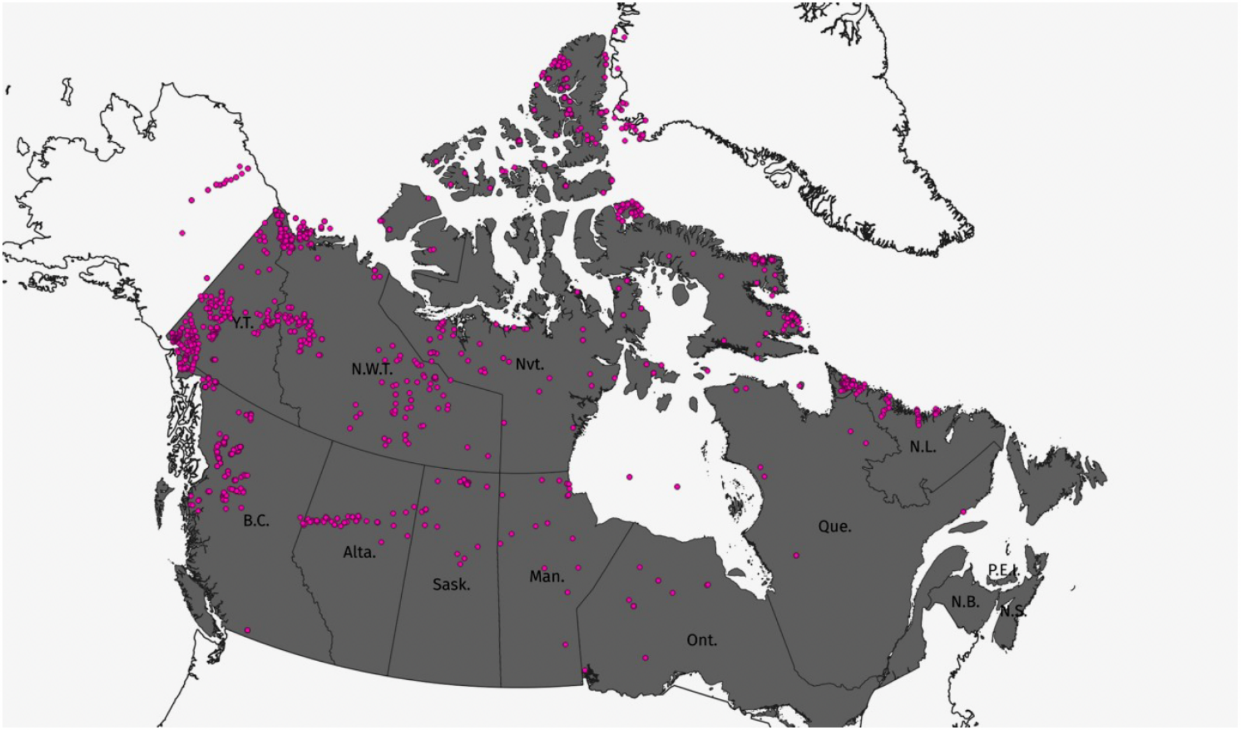
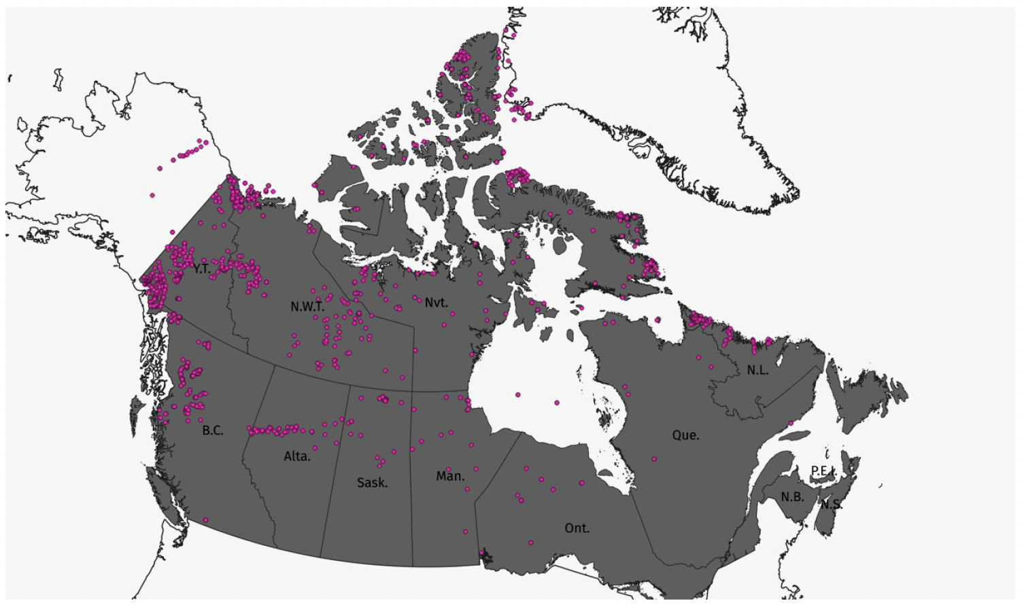
Locations of samples with LTT data in northern Canada. All published data are included in this report. Note: data from Alaska, Greenland and southern Canada were also extracted if included in the same publications as northern Canada LTT data. (Source: GSC Open File 9225)
1,427  Unique Samples | 50+ Years  Data Coverage (1970-2021) | 91  Data Sources
Data Accessibility: CATCH compilation data is also publicly accessible via Lithodat's open-access LithoSurfer and EarthBank platforms.

7. Data Extraction and Curation Methodology
7.1 Multi-Source Data Integration
Data extraction involved extensive data mining of all LTT data and associated metadata for northern Canada from 91 different data sources. The project required specialized approaches for different data formats:
Data Format | Extraction Method | Quality Control
Modern Digital Publications | Direct extraction from digital tables (copy/paste to Excel) | Row-by-row validation against source
Analogue Paper Reports | Manual data entry from physical documents | Double-entry verification
Non-Vectorized PDFs | OCR extraction with manual correction | Character-by-character validation
Published  Figures/Histograms | Digital extraction using image analysis tools | Statistical comparison to published summaries
Maps Without Coordinates | Georeferencing using GIS software | Cross-validation with regional geology
7.2 Comprehensive Metadata Capture
At the sample level, CATCH captures extensive metadata to enable reuse and reinterpretation of historical data:
Sample Metadata: Name, coordinates, location name/description, location type, sampling method, rock type, stratigraphic unit, elevation
Analytical Metadata: Laboratory, analyst, analytical method, measurement date, equipment used
Kinetic Parameters: Dpar, chlorine content, radiation damage, etching conditions—essential for thermal history modeling
Provenance Metadata: Funding sources, chief investigator, publication reference, digital object identifier (DOI)
Quality Metrics: Number of grains analyzed, track counts, uncertainties, quality flags

7.3 Georeferencing and Spatial Integration
For publications where sample coordinates were not provided, locations were determined via systematic
georeferencing of geologic maps. This process involved:
Digital extraction of geologic maps from publications
Georeferencing maps using GIS software (QGIS, ArcGIS)
Digitizing sample locations from georeferenced maps
Cross-validation with regional geological frameworks
Assignment of confidence levels to georeferenced coordinates
7.4 Data Reusability Framework
A critical design principle of CATCH is enabling functional reuse of historical data through modern analytical lenses.
This is essential because:
Evolving Kinetic Models: Laboratory-defined models for thermal diffusion and annealing are routinely updated
and improved
New Modeling Software: Advanced codes for numerical thermal history modeling are continually published
Big Data Approaches: Modern methods derive regional geologic histories from large LTT datasets requiring
comprehensive metadata
By capturing comprehensive analytical metadata, CATCH ensures that a single apatite fission track age from a 1970s
publication (with minimal reported metadata) can be reanalyzed using modern kinetic models alongside contemporary

8 Government Partnership and Governance
Lithodat's collaboration with Natural Resources Canada (NRCan) on the CATCH database demonstrates:
Federal Agency Collaboration: Multi-year partnership with Canadian federal government geological survey
(GSC)
National Infrastructure Development: Building mission-critical data infrastructure for national geoscience
priorities
Official Publications: CATCH work published as GSC Open File 9225 with full government co-authorship
Long-Term Sustainability: Database designed for ongoing curation and expansion beyond initial compilation
Open Science Mandate: Full public accessibility via AusGeochem platform aligns with government open data
policies

9. Government Partnership and Governance
Lithodat's collaboration with Natural Resources Canada (NRCan) on the CATCH database demonstrates:
- Federal Agency Collaboration: Multi-year partnership with Canadian federal government geological survey (GSC)
- National Infrastructure Development: Building mission-critical data infrastructure for national geoscience priorities
- Official Publications: CATCH work published as GSC Open File 9225 with full government co-authorship
- Long-Term Sustainability: Database designed for ongoing curation and expansion beyond initial compilation
- Open Science Mandate: Full public accessibility via AusGeochem platform aligns with government open data policies
10. Relevance to GDAC-SA Project
The CATCH database demonstrates Lithodat's proven capability to address GDAC-SA's core challenges in national geological data integration:
Multi-Decade Data Integration: Successfully compiled and harmonized data from 50+ years of publications (1970-2021), including digital and analogue sources—directly analogous to GDAC's challenge of integrating historical and modern Saudi geological survey data
Legacy Data Digitization: Developed systematic approaches to extract data from paper reports, non-vectorized PDFs, and published figures (e.g., digitizing histograms, georeferencing sample locations)—critical for GDAC's historical data integration requirements
Complex Metadata Management: Captured comprehensive analytical metadata including sample coordinates, rock types, stratigraphic units, analytical methods, kinetic parameters, and quality control metrics—demonstrating expertise in geoscientific metadata frameworks
FAIR Data Principles: Designed database structure to be Findable, Accessible, Interoperable, and Reusable, with open-access delivery via AusGeochem platform—aligning with GDAC's open science mandate
National-Scale Geoscientific Infrastructure: Created standardized templates and workflows for ongoing data submission by Canadian researchers—providing blueprint for GDAC's data ingestion framework
Government Partnership Excellence: Multi-year collaboration with Natural Resources Canada (federal agency) demonstrates capability to deliver mission-critical infrastructure for national geological surveys
Critical GDAC-SA Alignment: The CATCH database solves the exact multi-decade data integration problem that GDAC-SA faces. Where GDAC must digitize and integrate 50+ years of Saudi geological survey data with inconsistent formats, CATCH successfully harmonized Canadian thermochronology data spanning the same timeframe with equally diverse data structures. The data extraction methodologies, quality control frameworks, and database architectures are directly transferable to the Saudi context.
11. Future Expansion: Southern Canada and Thermal Modeling
The CATCH database is being expanded through a series of GSC Open Files:
Open File 9225 (Published 2025): Northern Canada compilation (this work)
Open File 2 (Upcoming 2026): Southern Canada LTT compilation plus thermal history models and metadata
Open File 3 (Upcoming 2026): Canadian Thermal Histories compilations
This phased approach demonstrates Lithodat's capability to deliver large-scale national infrastructure projects in
stages, with each phase building on previous work.
12. Official Publication and Citation
Official Citation:
Powell, J.W., Kellett, D.A., Kohlmann, F., and McMillan, M., 2025. Canadian ThermoCHronology (CATCH) database: northern Canada
compilation; Geological Survey of Canada, Open File 9225, 1 .zip file.
Publisher: Natural Resources Canada, Geological Survey of Canada
ISBN: 978-0-660-74235-9
Catalogue No.: M183-2/9225E-PDF
ISSN: 2816-7155
Lithodat Authors:

F. Kohlmann (Lithodat Pty Ltd, Melbourne, Australia)
M. McMillan (Lithodat Pty Ltd & University of Melbourne, Australia)
Copyright: © His Majesty the King in Right of Canada, as represented by the Minister of Natural Resources, 2025
13. Key Takeaways for GDAC-SA
Proven National-Scale Data Integration: The CATCH database demonstrates Lithodat's capability to deliver national geological data infrastructure for federal government agencies. The project's scope (1,427 samples, 91 data sources, 50 years of legacy data) is directly comparable to GDAC-SA's requirements. Methodologies developed for CATCH, including legacy data digitization, multi-format extraction pipelines, georeferencing workflows, and FAIR data implementation, are immediately transferable to the Saudi geological survey context.
Government Partnership Excellence: Lithodat's multi-year collaboration with Natural Resources Canada (federal agency equivalent to Saudi Geological Survey) resulted in official government publications and long-term national infrastructure. This demonstrates capability to work within government procurement frameworks, deliver mission-critical infrastructure, and maintain partnerships through multi-phase projects, essential qualifications for the GDAC-SA contract.

